Asia-China-Coin-Knife Money-H 4.50 R4

SHAPE \\* MERGEFORMAT 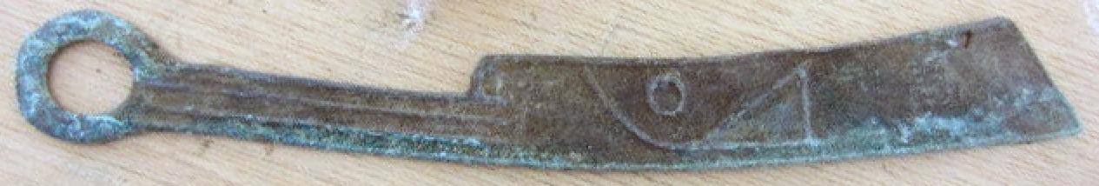 SHAPE \\* MERGEFORMAT 